Guinea-Bissau

## Political Stability Estimate Data

The data set shows the political stability estimate of the country each year.

## # A tibble: 19 x 5  
## country iso3c date stability stabilityCategory4   
## <chr> <chr> <dbl> <dbl> <chr>   
## 1 Guinea-Bissau GNB 1996 -1.54 highly unstable   
## 2 Guinea-Bissau GNB 1998 -1.86 highly unstable   
## 3 Guinea-Bissau GNB 2000 -0.350 moderately unstable  
## 4 Guinea-Bissau GNB 2002 -0.729 moderately unstable  
## 5 Guinea-Bissau GNB 2003 -0.494 moderately unstable  
## 6 Guinea-Bissau GNB 2004 -0.379 moderately unstable  
## 7 Guinea-Bissau GNB 2005 -0.565 moderately unstable  
## 8 Guinea-Bissau GNB 2006 -0.495 moderately unstable  
## 9 Guinea-Bissau GNB 2007 -0.460 moderately unstable  
## 10 Guinea-Bissau GNB 2008 -0.709 moderately unstable  
## 11 Guinea-Bissau GNB 2009 -0.666 moderately unstable  
## 12 Guinea-Bissau GNB 2010 -0.691 moderately unstable  
## 13 Guinea-Bissau GNB 2011 -0.754 moderately unstable  
## 14 Guinea-Bissau GNB 2012 -0.965 moderately unstable  
## 15 Guinea-Bissau GNB 2013 -0.900 moderately unstable  
## 16 Guinea-Bissau GNB 2014 -0.706 moderately unstable  
## 17 Guinea-Bissau GNB 2015 -0.518 moderately unstable  
## 18 Guinea-Bissau GNB 2016 -0.443 moderately unstable  
## 19 Guinea-Bissau GNB 2017 -0.600 moderately unstable

## Political Stability Estimate Plot

The plot shows the trends of stabilization and destabilization for the each country.

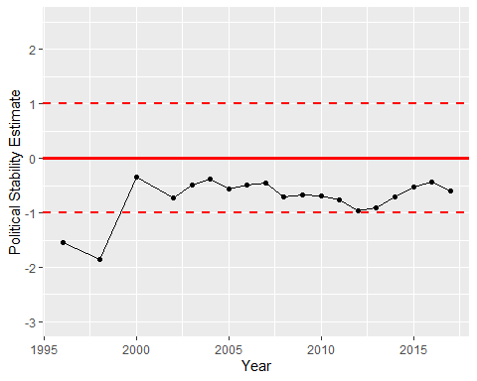

Political Stability Trend